Reqy requirement traceability matrix artifact

A major artifact for traceability is the requirement traceability matrix (RTM). Requirements tracing is the process of documenting the links between the requirements for the system being built and the artifacts developed to implement and verify those requirements.

Change history
Date | Name | Description | Reason
2012-08-02 | Oliver | Initial document

Table of contents
1 Change history 1
2 Table of contents 1
3 Syntax 2
4 Dependencies mode 2
5 Repository checks 2

Overview
Requirements tracing helps the project team to understand which parts of the design and code implement the user's requirements, and which tests are necessary to verify that the user's requirements have been implemented correctly.

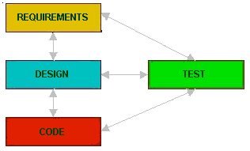

In the diagram, based on the requirements the design is carried out and based on the design, the codes are developed. Finally, based on these the tests are created. At any point of time , there is always the provision for checking which test case was developed for which design and for which requirement that design was carried out. Such a kind of Traceability in the form of a matrix is the Traceability Matrix.

Template example
Requirement name | Description | Use case | Design | Code ref | Test case | Acceptance test | Complete
1.1 My requirement | A superfolous requirement | 1.1_UC | Design/Not much use.doc | Code/modulex/test.py | Testcase/1.1.2-tc.txt | Acceptance/1.1_ac.txt | Yes
1.2 My other requirement | Not much more usefull |  |  | Code/moduley/fine.py |  |  | No

First requirement is complete because the requirement has one or more traces for each artifact type. The second is incomplete because it is missing several traces. The traceability matrix provides an overview of the projects completeness in terms that is understandable to the client.

